FLORIDA DEPARTMENT OF AGRICULTURE AND CONSUMER SERVICES
PEST CONTROL RESEARCH & EDUCATION PROPOSAL

Identification of Invasive Termite Species, Native Economic Species, and Future Termite Invaders of Florida

Rudolf H. Scheffrahn, Professor of Entomology
Institute of Food and Agricultural Sciences, University of Florida
Fort Lauderdale Research & Education Center
3205 College Avenue, Davie, Florida 33314
rhsc@ufl.edu
954-577-6312

For 40 years, I have strived to teach pest control operators, homeowners, and State inspectors of Florida on how to ID termites, termite wings, and their damage. This would be a great opportunity to share my experience in a single product before I retire.

COVER PAGE
RESEARCH & EDUCATION TOPIC PRIORITES
- Invasive Termites Species/Identification
- Insect Identification Tools
- Update on Formosan Termites
ABSTRACT
Florida’s tropical/subtropical climate and large urban centers support a large array of structural and household insect pests. Florida also has a very prominent pest control industry that provides the citizens of the State with vital services to eliminate pestiferous species. An overriding component and first step for pest control providers is the identification of the target pest(s) involved. Termites, because of their damage potential, are the most economically important structural pests in the State. Termites require proper identification as varied control procedures are aimed at specific groups, control methods are highly technical, and treatments are more costly than for other household pest groups. The aim of this project is to provide termite species characters (all castes), distribution, damage, flight characteristics, and niche requirements using a web-based platform that can be accessed in the field during the inspection process. Established invasive species, native species, and those that have the potential for introduction in the State will be addressed.

Page 1

INTRODUCTION
Currently, there are seven invasive species in Florida that cause some or major economic harm (Table 1). The first invasive termite species in Florida, the West Indian drywood termite (Cryptotermes brevis, WIDT), was identified in Key West by T. E. Snyder in 1918 (Kofoid 1934). This species is now widespread in central, southern, and coastal regions of the State. The second invasive species, the Formosan Subterranean termite (Coptotermes formosanus, FST), appeared in the State in the mid-1980s, and is likewise widely distributed in Florida (Scheffrahn & Su 2005). The western drywood termite (Incisitermes minor) began is appearance about the same time as the FST (Cabrera & Scheffrahn 2001). In 1995, the Cuban subterranean termite (Heterotermes cardini) was detected in Miami (Scheffrahn & Su 1995) followed by the Asian subterranean termie (Coptotermes gestroi, AST) in 1996 (Su et al. 1997). Recently (2001) the conehead termite (Nasutitermes corniger) became established in Broward (Scheffrahn et al. 2002) and Palm Beach Counties. Amitermes wheeleri has been determined to be a synonym of A. floridanus (Two other non-native Nasutitermes species (N. acajutlae and N. nigriceps, Scheffrahn and Crowe 2011) have been identified in Florida but their establishment is uncertain. Several other species of Cryptotermes, Incisitermes, and Coptotermes have the potential for establishment if Florida (Barakat et al. 2024, Scheffrahn 2019).
Termite identification skills of field inspectors working either in the private sector or for State agencies is vital for the determination of proper management techniques and legal challenges. For example, fumigation is a primary treatment for drywood termites while soil treatment or baits are used for subterranean termites. A prescribed treatment effective for one group will not be efficacious for another. When a structure is inspected, a search commences for termite specimens and/or damage. These can be winged termites (alates), wings, soldiers, and/or workers. On occasion, termite specimens are not found so the inspector must be trained on the recognition of termite damage or fecal material. Decay or other insect damage must also not be confused with termite activity.
Termite identification can be made more comprehensible than currently available resources. For example, popular books for pest identification (e.g., Ebeling 1978, Mallis 2011, Bennett et al. 2010) are directed at a national audience and are burdened by technical vocabulary. Also termite identification keys rely on soldiers or winged imagos. Worker characters and wings alone are useful for generic identification.
Geographical location or temporal activity of a termite infestation also assists in their identification. It would be important to verify a species that has not previously found in a region of the State. For example, discovery of AST in northern Florida would be novel and important. Flight season and weather conditions also support proper identification. For example, peak flights for AST occur in crepuscular (evening) hours from February to April with FST flies at the beginning of the rainy season (Chouvenc et al. 2017). The WIDT tends to peak in the rainy season but flights can occur any month of the year. In addition to invasive species, Florida harbors native species that are economic pests (e.g., Reticulitermes species (Table 2).
Page 2
PLAN OF RESEARCH
With the advent of the internet, print resources for training and education are becoming increasingly archaic. I am proficient in the WIX® website building platform for displaying content such as images, identification keys, and maps. New microphotographs will be taken with a Leica M205C stereomicroscope controlled by Leica Application Suite ver. 3.0 montage software (Fig. 1). Specimens will be submerged in hand sanitizer (70% ethanol) inside a plastic Petri dish. Distribution maps (Fig. 2) will be produced using ArcGIS Pro Intelligence 3.0 software (Redlands, Calif.).
Over a span of 40 years, my colleagues and I have accumulated thousands of field photographs of termites and termite damage throughout the State (Fig. 3). I also curate the largest contemporary termite collection in the world (University of Florida Termite Collection, UFTC, 47,173 colony samples as of this writing). A total of 7,953 samples are from Florida which is the main source of photographic content. The collection is georeferenced and maintained on Excel (Fig. 4).
High-resolution field photographs are now in reach with smart phones or low-cost digital microscopes (e.g., Avangard Optics AN-E500; $29.99, Fig. 5) for pest control operators, State inspectors, property managers, and others seeking termite identification. Images can be easily transferred from the microscope to a laptop by USB for documentation/business records. The development of artificial intelligence software will further advance identification by machine learning (Tannous et al. 2023) using the images developed in this project.
As Florida’s climate slowly warms and marine traffic continues to escalate, it is very probable that new exotic pest species will become established in Florida. These species will originate from climates similar to Florida. Table 3 provides my expectation of termite species that have the greatest likelihood of permanent establishment. These species will be included in this work along with already established termites in Florida.
The following topics for each species will be addressed in detail:
- Comparative photographs of termite alates, soldiers, and workers to the same scale
- Characters for drywood, subterranean, and arboreal termite ID in the field
- Flight seasons, weather conditions, and time of day
- Termite damage with fungal decay and wood-boring beetles
- Photographs of flight aftermath (wings, dried bodies) in typical locations
- Photographs of fecal matter, wood damage, flight/kick-out holes, and other evidence
- Updated distribution maps of all economic termite species in Florida

Page 3

LITERATURE CITED
Barakat, H., Scheffrahn, R. H., El Gohary, E., Bahder, B. W., Mahmoud, D. M., Salama, M. S., & Ghallab, E. H. (2024). First record of the invasive Asian subterranean termite, Coptotermes gestroi, from Egypt. Bulletin of Insectology, 77(1), 54-60. http://www.bulletinofinsectology.org/pdfarticles/vol77-2024-054-060barakat.pdf
Bennett, G. W., Corrigan, R., & Owens, J. (2010) Truman’s Scientific Guide to Pest Management Operations. Purdue University. 624 pp.
Cabrera, B. J., & Scheffrahn, R. H. (2001). Western drywood termite, Incisitermes minor (Hagen)(Insecta: Isoptera: Kalotermitidae). UF/IFAS Extension EENY, 248, 1-7.
Chouvenc, T., Scheffrahn, R. H., Mullins, A. J., & Su, N. Y. (2017). Flight phenology of two Coptotermes species (Isoptera: Rhinotermitidae) in southeastern Florida. Journal of Economic Entomology, 110(4), 1693-1704. https://doi.org/10.1093/jee/tox136
Ebeling, W. (1978). Urban Entomology. University of California Press, 695 pp. https://entomology.ucr.edu/ebeling
Kofoid, C.A., ed. 1934. Termites and termite control. 2nd ed. Berkeley: University of California Press, 795 pp.
Mallis, A. (2011). Handbook of Pest Control. Franzak & Foster Co. Cleveland, OH. 1600 pp. https://www.giemedia.com/product/mallis-handbook/
Scheffrahn, R. H. (2019). Expanded New World distributions of genera in the termite family Kalotermitidae. Sociobiology, 66(1), 136-153. https://doi.org/10.13102/sociobiology.v66i1.3492
Scheffrahn, R. H. (2022). Amitermes californicus Banks, 1920 (Isoptera, Termitidae, Termitinae) resurrected after ninety years of synonymy and A. floridensis Scheffrahn, 1989 synonymized into A. wheeleri (Desneux, 1906). Zootaxa, 5128(4), 581-588. https://doi.org/10.11646/zootaxa.5128.4.7
Scheffrahn, R. H., & Crowe, W. (2011). Ship-borne termite (Isoptera) border interceptions in Australia and onboard infestations in Florida, 1986–2009. Florida Entomologist, 94(1), 57-63. https://doi.org/10.1653/024.094.0108
Scheffrahn, R. H., & Su, N. Y. (1995). A new subterranean termite introduced to Florida: Heterotermes Froggatt (Rhinotermitidae: Heterotermitinae) established in Miami. The Florida Entomologist, 78(4), 623-627. https://doi.org/10.2307/3496052
Scheffrahn, R. H., & Su, N. Y. (2005). Distribution of the termite genus Coptotermes (Isoptera: Rhinotermitidae) in Florida. Florida Entomologist, 88(2), 201-203. https://doi.org/10.1653/0015-4040(2005)088[0201:DOTTGC]2.0.CO;2

Page 4
Scheffrahn, R. H., Cabrera, B. J., Kern Jr, W. H., & Su, N. Y. (2002). Nasutitermes costalis (Isoptera: Termitidae) in Florida: first record of a non-endemic establishment by a higher termite. Florida Entomologist, 85(1), 273-275. https://doi.org/10.1653/0015-4040(2002)085[0273:NCITIF]2.0.CO;2
Su, N. Y., Scheffrahn, R. H., & Weissling, T. (1997). A new introduction of a subterranean termite, Coptotermes havilandi Holmgren (Isoptera: Rhinotermitidae) in Miami, Florida. The Florida Entomologist, 80(3), 408-411. https://doi.org/10.2307/3495774
Tannous, M., Stefanini, C., & Romano, D. (2023). A deep-learning-based detection approach for the identification of insect species of economic importance. Insects, 14(2), 148. https://doi.org/10.3390/insects14020148

Page 5

COST ANALYSIS
Contractor: University of Florida
Proposal Title: Identification of Invasive Termite Species, Native Economic Species, and Future Termite Invaders of Florida
Period of Service: Calander year 2025

Budget | Total amount funded by the contractor (University of Florida) | Effort/Time percentage allocated to this project only | Amournt allocated to conduct this project by FDACS
Salaries
Dr. Rudolf Scheffrahn | $155,427 | 14% | $21,760
OPS Lab Assistant | $40,000 | 50% | $20,000
Fringe Benefits
Dr. Rudolf Scheffrahn | $46,783 (30.1%) | 14% | $6,550
OPS Lab Assistant | $1,680 (4.2%) | 50% | $840
Travel
Field sites | $0 | 100% | $500
Micellaneous
Leica software update | $1,200 | 100% | $1,200
Computer CPU update | $659 | 100% | $659
Indirect Cost | 10% | 100% | $5,085
TOTAL CONTRACT VALUE |  |  | $56,594

Page 6
ENVIRONMENT

All research will be conducted in my laboratory (Room 221, 750 ft²) at the UF/IFAS Fort Lauderdale Research and Education Center. A microscope room (Room 121A, 50 ft²) houses a Leica M205C stereomicroscope and a Leica CTR 5500 compound microscope with phase-contrast optics. The University of Florida Termite Collection is housed in a separate room (Room 235, 100 ft²).

CV of PI

Name: Rudolf H. Scheffrahn
Title: Professor of Entomology
Affiliation: UF/IFAS Fort Lauderdale Research and Education Center
Highest degree: PhD. , Entomology 1984, University of California, Riverside
Current extramural support: none (I will retire February, 2026).

Previous refereed publications:
Four hundred ten refereed career publications: https://scholar.google.com/citations?user=jJ7325IAAAAJ&hl=en&oi=ao
Google scholar citations (2024): All 10,239, h-index 54, i10-index 202.
Recognized in 2024 by UF/IFAS Research Dean for high career citations.
Five most recent publications relevant to proposal:

Barakat, H., Scheffrahn, R. H., El Gohary, E., Bahder, B. W., Mahmoud, D. M., Salama, M. S., & Ghallab, E. H. (2024). First record of the invasive Asian subterranean termite, Coptotermes gestroi, from Egypt. Bulletin of Insectology, 77(1), 54-60. http://www.bulletinofinsectology.org/pdfarticles/vol77-2024-054-060barakat.pdf

Scheffrahn, R. H. (2023). Biogeography of Coptotermes formosanus. In Biology and Management of the Formosan Subterranean Termite and Related Species (pp. 8-25). GB: CABI. https://www.cabidigitallibrary.org/doi/book/10.1079/9781800621596.0000

Scheffrahn, R. H. (2024). New records for Coatitermes pallidus (Snyder, 1926) and Coatitermes clevelandi (Snyder, 1926)(Isoptera, Termitidae, Nasutitermitinae) from Amazonia. Check List, 20(3), 700-705. https://doi.org/10.15560/20.3.700

Page 7

Scheffrahn, R. H., Austin, J. W., & Szalanski, A. L. (2024). Two new Incisitermes (Isoptera: Kalotermitidae) species from the Caribbean Basin, genetic relationships with other regional Incisitermes, and synonymy of Incisitermes tabogae with I. schwarzi. Zootaxa, 5428(3), 427-439. https://doi.org/10.11646/zootaxa.5428.3.6

Scheffrahn, R. H., Roisin, Y., Szalanski, A. L., Austin, J. W., & Duquesne, E. (2024). Expanded range of Nasutitermes callimorphus Mathews, 1977 (Isoptera: Termitidae: Nasutitermitinae), comparison with N. corniger (Motschulsky, 1855) and N. ephratae (Holmgren, 1910), and synonymy of N. dasyopsis Thorne, 1989 into N. nigriceps (Haldeman, 1854). Zootaxa, 5507(1), 57-78. https://doi.org/10.11646/zootaxa.5507.1.2

Previous FDACS funding in the last 5 years:

Evaluation of clearance devices for sulfuryl fluoride structural fumigation (2020), amount funded: $10,000.

Florida Fumigation Manual Second Edition (2021) https://flrec.ifas.ufl.edu/florida-fumigation-manual/ Executive editor and contributor.

Page 8

Table 1. Invasive termite species that are established in Florida.
Taxon | Region in Florida
Kalotermitidae
Cryptotermes brevis | Statewide
Incisitermes minor | Statewide, spotty
Heterotermitidae
Coptotermes formosanus | Statewide
Coptotermes gestroi | Central/Southern
Heterotermes cardini | Southeast
Amitermitinae
Amitermes wheeleri | Central/Southwest
Nasutitermitinae
Nasutitermes corniger | Broward, Palm Beach Cos.

Table 2. Native Florida termite species that occur in structures.
Taxon | Structural threat
Kalotermitidae
Cryptotermes cavifrons | none*
Incisitermes snyderi | Wood exposed to moisture
Neotermes castaneus | none*
Heterotermitidae
Reticulitermes flavipes | Subterranean attack
Reticulitermes hageni | Subterranean attack
Reticulitermes virginicus | Subterranean attack
Psammotermitidae
Prorhinotermes simplex | Foraging on surfaces
*Alates may fly into structures without viability.

Page 9

Table 3. Invasive termite species likely to become established in Florida.
Taxon | Current distribution nearest to Florida*
Kalotermitidae
Cryptotermes dudleyi | Jamaica
Cryptotermes havilandi | St. Thomas, U.S. Virgin Islands
Heterotermitidae
Coptotermes heimi | United Arab Emirates
Heterotermes tenuis | St. Lucia
Amitermitinae
Termes hispaniolae | The Bahamas
Microcerotermitnae
Microcerotermes arboreus | Grand Cayman
Nasutitermitinae
Nasutitermes acajutlae | West Palm Beach**
Nasutitermes nigriceps | Grand Cayman
*Recorded in the University of Florida Termite Collection database.
**Intercepted, not established. Established in St. Thomas

Page 10

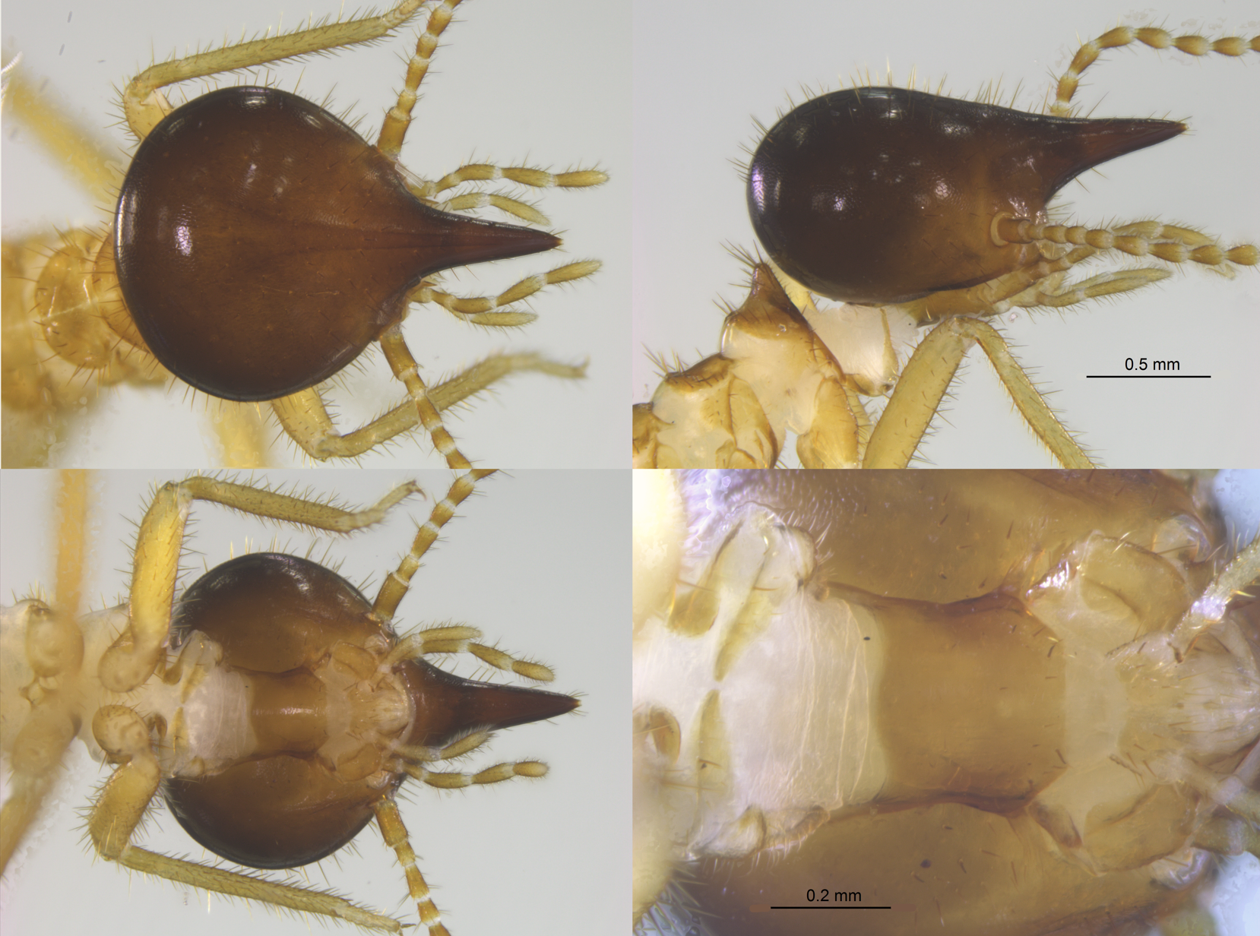
Figure 1. Nasutitermes acajutlae soldier collected from a nest at the Port of Palm Beach in 2024.

Page 11

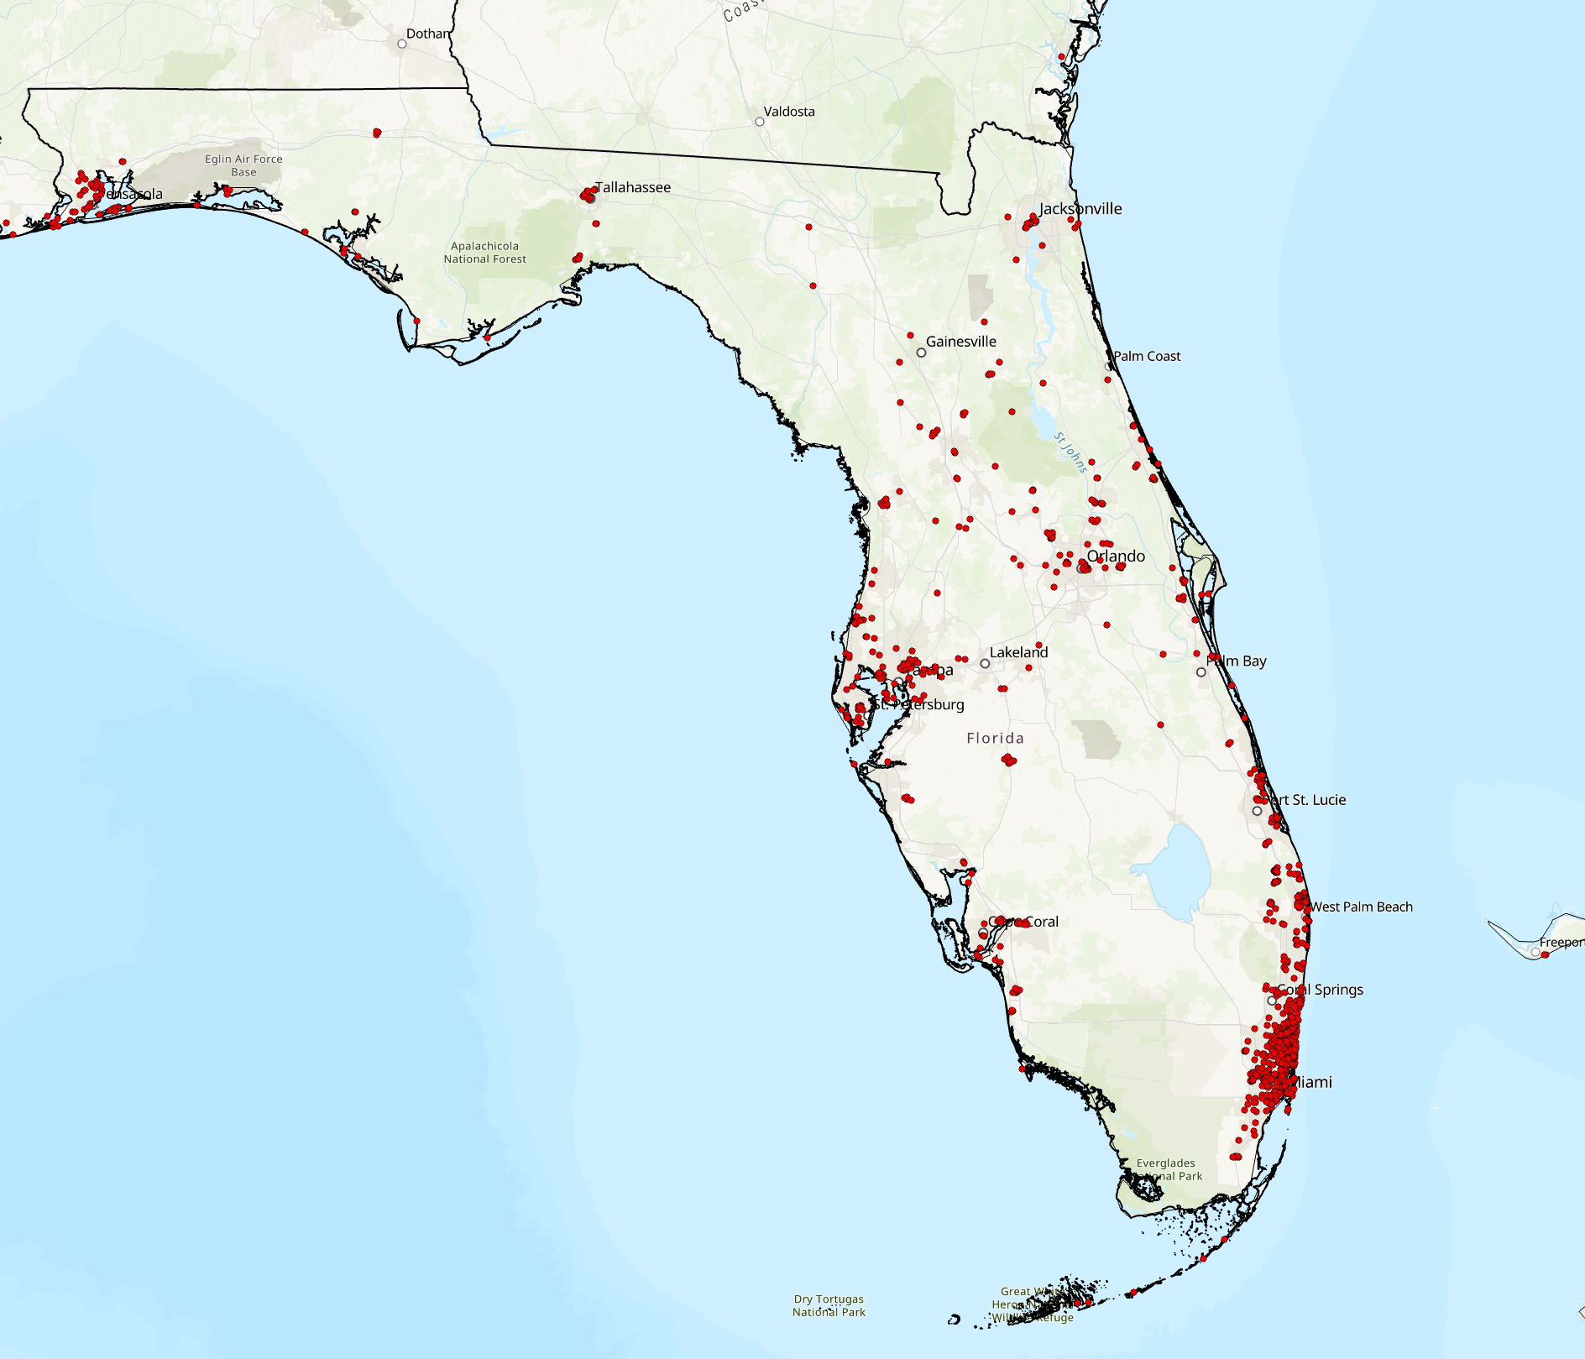
Figure 2. Localities of the Formosan subterranean termite based on holdings in the University of Florida Termite Collection.

Page 12
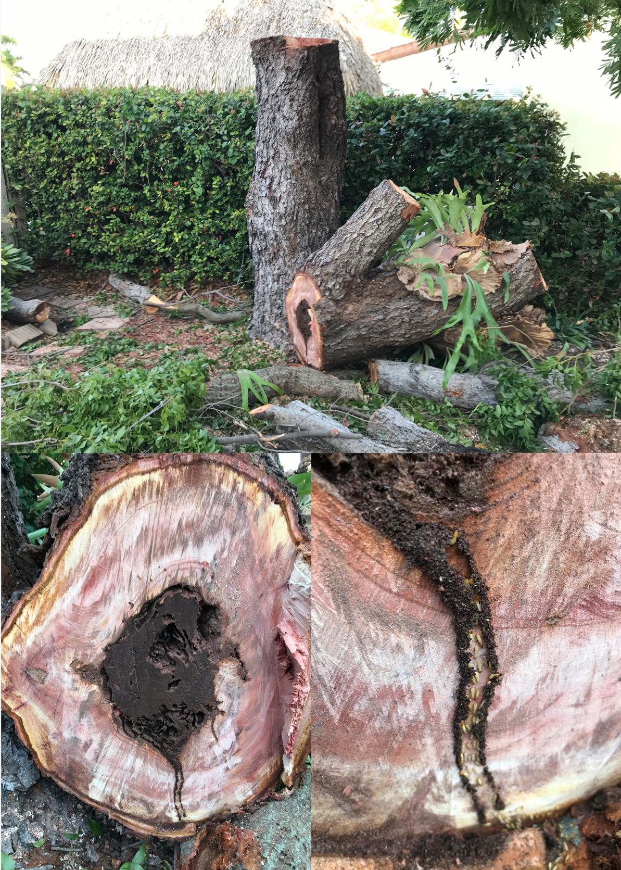
Figure 3. Live mahogany tree infested by the Asian subterranean termite in Hollywood, Florida.
Page 13

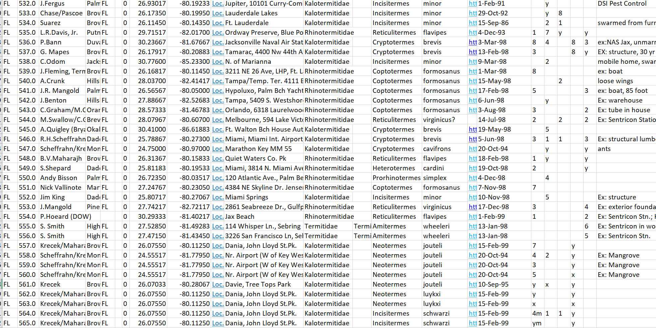
Figure 4. Screen shot of part of the University of Florida Termite Collection database.

Page 14
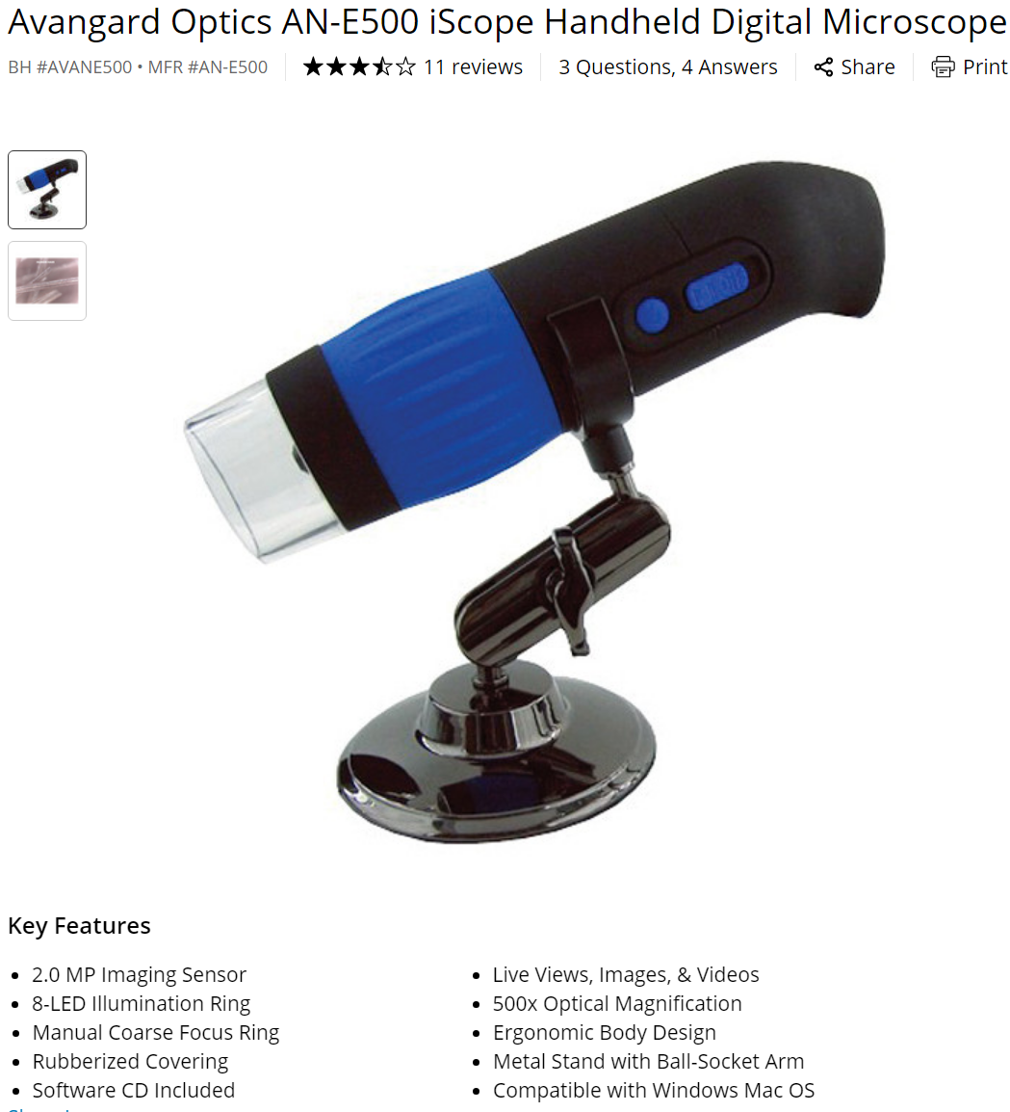
Figure 5. Example of a low-cost digital microscope for termite/insect identification.

Page 15

